You are required to use database ShipDB for this problem

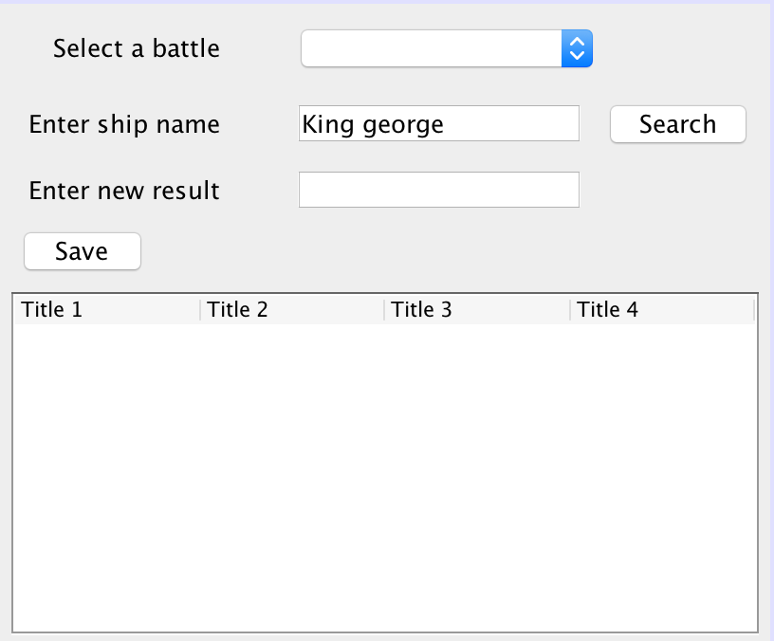

**Requirements:**

* Load all battles to dropdownlist, output battle name
* Output information of all outcomes to jtable

When users select a battle from dropdownlist and enter value for ship name and click on “Search”, output result of selected outcome to textfield “new result”, output an error message if no outcome is found.

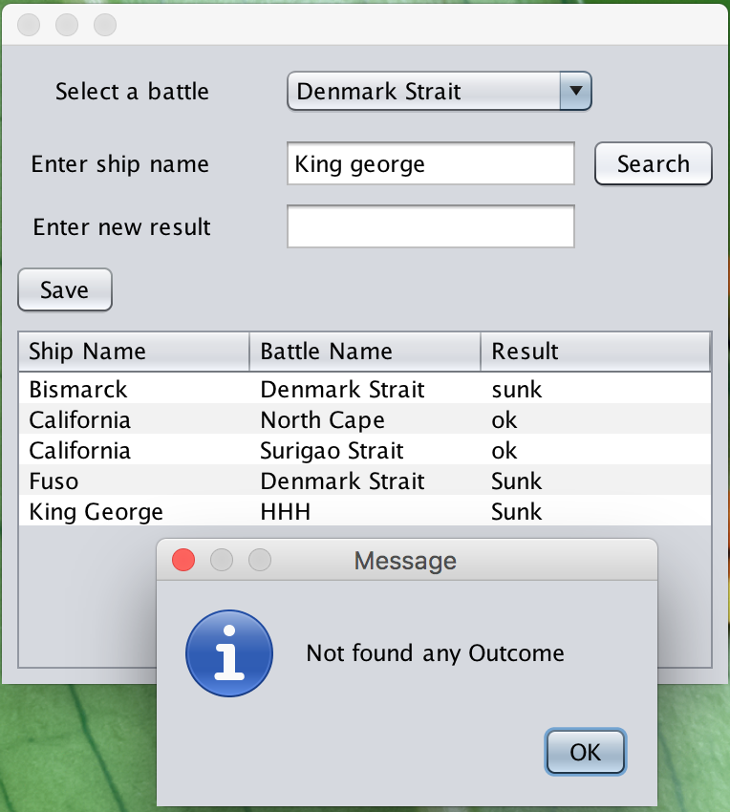

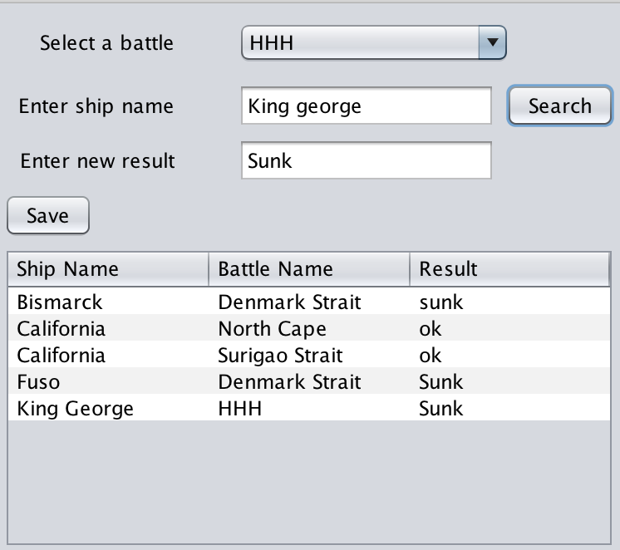

When users enter new value for result and click on “**Save**”, update information of selected Outcome to Outcomes table and output information of all outcomes to jtable.

